%Finite Impulse Response System – Thi T. Le

%This is one of interesting task in DSP that I want to share. The task is

%using Spectrum analysis to define type and properties of your filter.

% Original file noisy2.wav

%Step1: Using spectrogram to mark which part is noise and which part is

%signal

[sound_sample,sampling_rate]=audioread('noisy2.wav');

spectrogram (sound_sample,256,128,256,sampling_rate,'yaxis');

>>

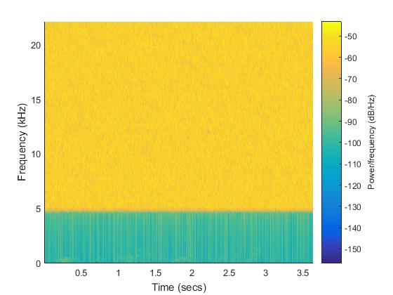

% From this we can see the signal in the range of frequency from 0 to 5 kHz

% and level in dB around from -170 to -130 dB. The rest is Noise

[signal,fs] = audioread('noisy2.wav');

plot(psd(spectrum.periodogram,signal,'Fs',fs,'NFFT',length(signal)));

>>

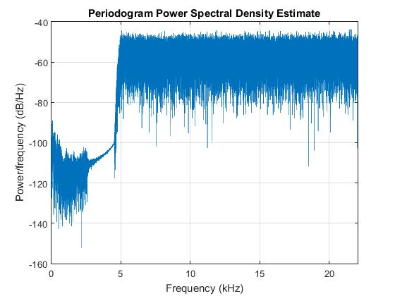

%With the power Spectral Density we can see it more clearly are and decide

%what type of filter and coefficient of it

%It clearly that Lowpass is the optional, cutoff frequency is 2kHz

%Stopband is 100dB (80dB still fine but I decide 100dB for sure)

%Transition bandwidth is 400Hz

Fs = 22050;

d= designfilt('lowpassfir', ...

'PassbandFrequency',2000,'StopbandFrequency',2400, ...

'PassbandRipple',1,'StopbandAttenuation',100, ...

'DesignMethod','equiripple','SampleRate',Fs);

fvtool(d);

>>

%This is the amplitude response we have from our filter.

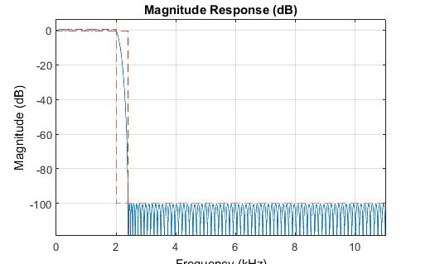

%We filter the signal and try to hear what we have. At first it’s nothing %but if you amplify the signal and also the rate sample you will able hear %something from it.

df= filter(d,signal);

audiowrite('afterwork.wav',df*50,Fs*2.5)

[y,Fs]=audioread('afterwork.wav');

sound(y,Fs);

%File name is afterwork.wav

%Optional, you can check the power spectral density again to see what you %have after filter the noise. I used this step to choice the coefficient of %my lowpass filter

plot(psd(spectrum.periodogram,df,'Fs',Fs,'NFFT',length(df)));

>>

